Name: __________________
Color your province or territory on this map
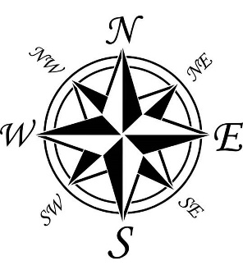
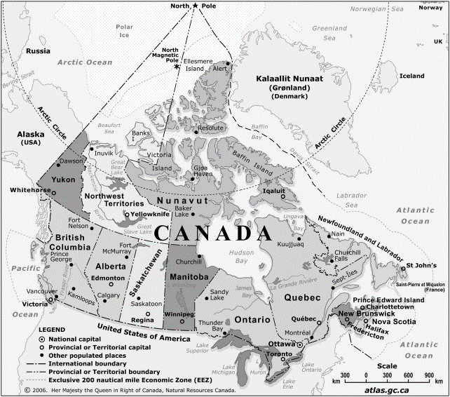

What is NORTH of your province? _________
What is SOUTH of your province? ________
What is EAST of your province? _________
What is WEST of your province? _________

2 Cool facts about my province that I learned were:
1) ____________________________________________________________________
_______________________________________________________________________
2) ______________________________________________________________________ ________________________________________________________________________
My Provincial gemstone is: _____________________________
What do the colors and symbol of your flag represent: ___________________________ ________________________________________________________________________________________________________________________________________________
Tourist spots in my province I would want travel to: ________________________________________________________________________

